NO MORE PAPER SIGN-IN SHEETS
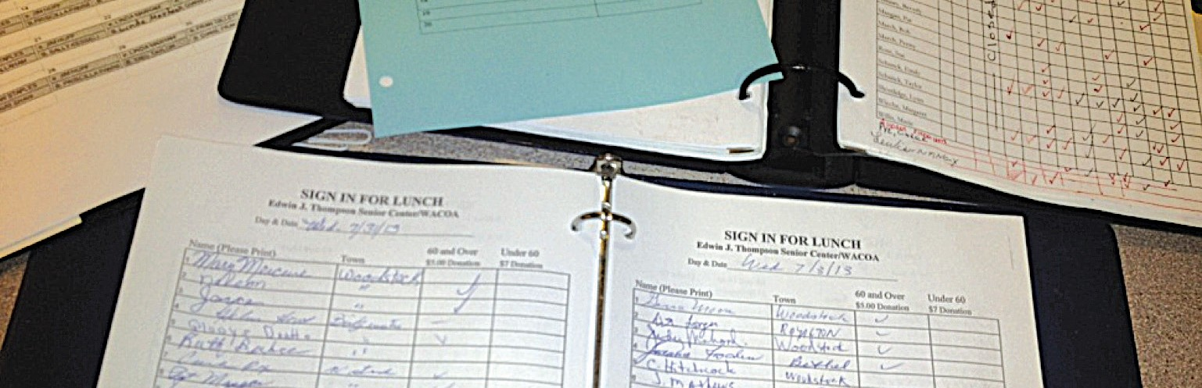
We will soon be using an automated check-in system. This new, efficient technology will help our future funding and programming efforts.
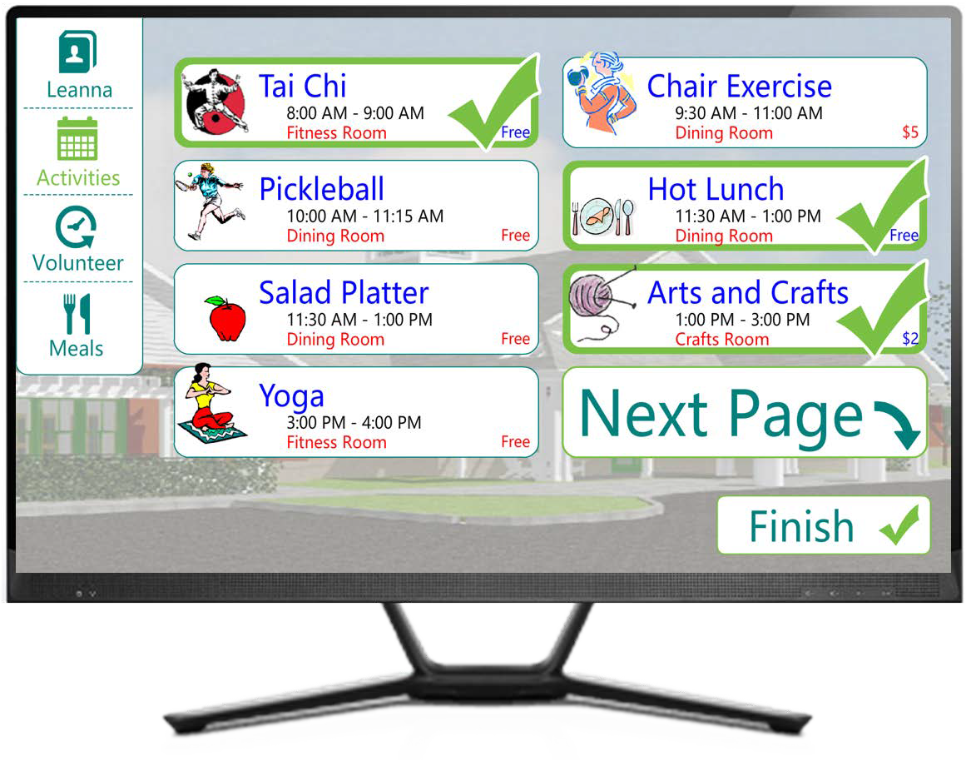
EASY AS 1-2-3
- 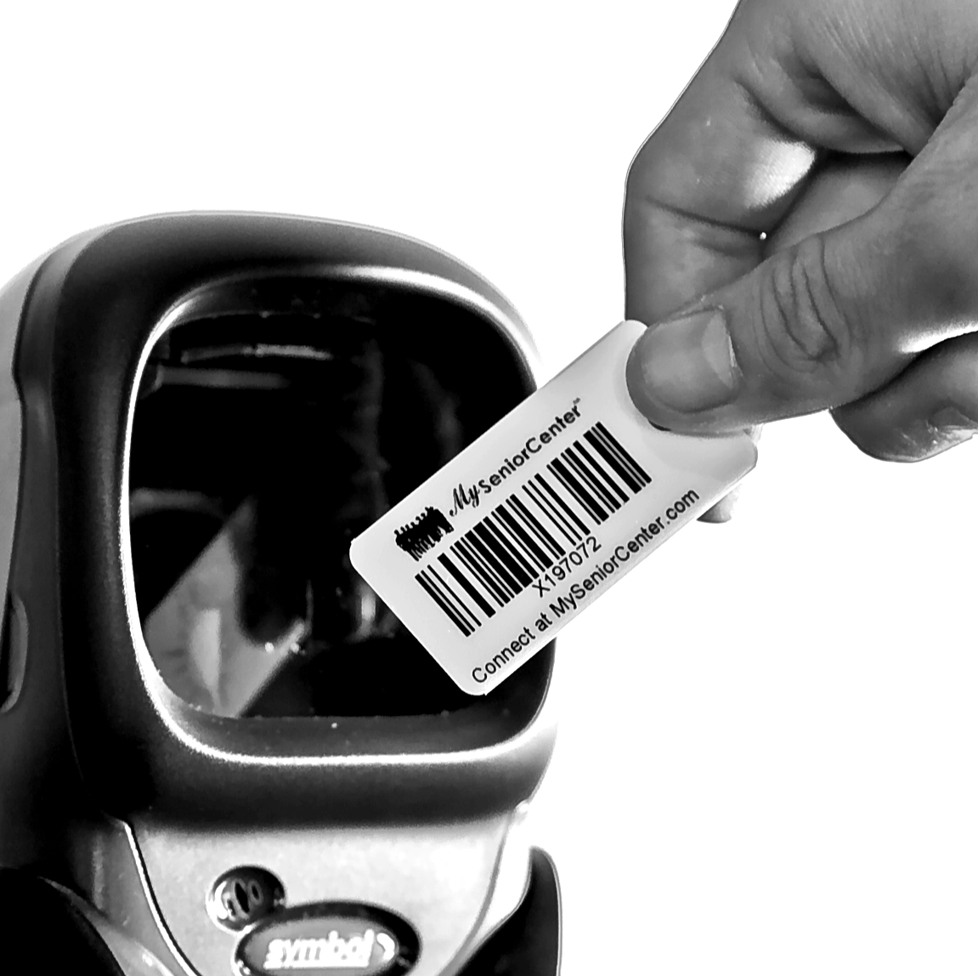Regular visitors and volunteers will receive a small keytag.
- Swipe your keytag across the scanner (or enter your name on the touchscreen).
- Press the touchscreen to select the activities you’ll be participating in that day.
PLEASE HELP US NOW BY FILLING OUT AN INFORMATION SHEET.

