NEWSLETTER ARTICLE

<Center Name> to Install Automated Check-In System in <Month>

A new, automated check-in system called MySeniorCenter will soon be installed in the foyer at <Center Name>. It’s specifically designed to help our staff members manage the various sign-ups and sign-ins, and improve the way we report our services to <town management, city management, county agency>.

Moreover, by quickly and accurately detailing which services we’re providing, the system will increase our chances of receiving additional funding in the future. Today MySeniorCenter is being used by over 900 senior centers across the U.S. and Canada—so it’s a proven tool.

A Change for the Better
The new system is extremely easy to use. Here’s how it works:

- All visitors and volunteers will receive a small keytag. (The card contains no personal information, but it will allow the new system to recognize you.)
- Instead of signing into our book, you’ll swipe your keytag at the scanner, or you can enter your name on the touchscreen (see below).
- Press the touchscreen to select the programs you’ll be participating in that day.
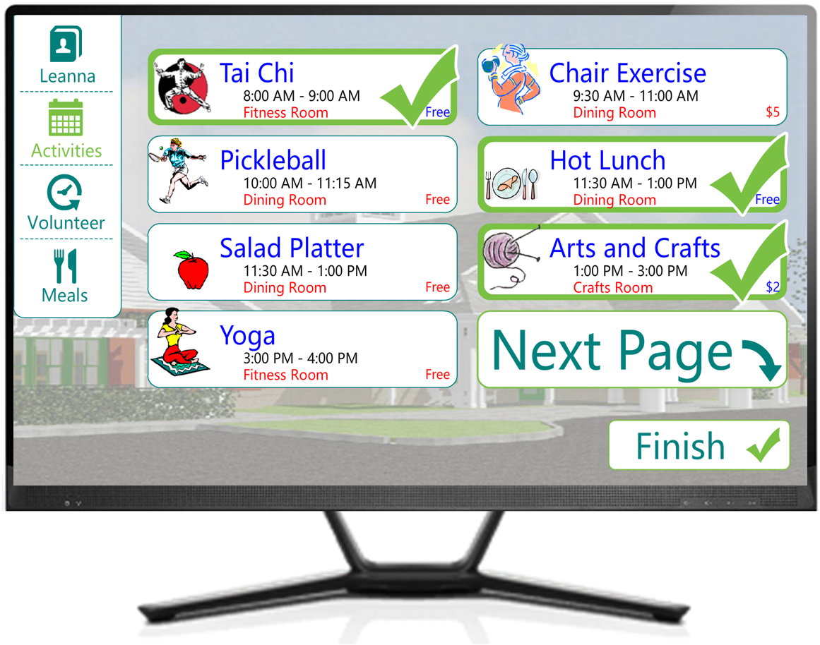
- Press FINISH.

A Smooth Transition
Even though MySeniorCenter is designed to be user-friendly, <Center Name> staff members and volunteers will be available in the foyer for the first <XX> weeks to help people operate the new check-in system. We want to make the transition as seamless as possible for everyone.

To reiterate, once MySeniorCenter is running smoothly, our registration process will be more efficient and we’ll stand a better chance of receiving funding for future activities.

MySeniorCenter will be installed on <Date>.

